**Worksheet-5**

**NOTE**

* **Kindly follow the instructions given in PPT T1-Turtle Graphics to enable scripting mode for Turtle in IDLE.**
* **Kindly go through PPT T2-Turtle Features attached in Mail before starting this Worksheet.**

Observation

1. Run the given code in IDLE and answer the questions that follow:

from turtle import *

my_turtle = Turtle()

my_turtle.shape("turtle")

my_turtle.pencolor("violet")

my_turtle.circle(90)

my_turtle.circle(90)

my_turtle.hideturtle()

1. How many circles do you see on screen after the execution of the code?

Answer:

1. Do you see the turtle after the completion of the code?

Answer:

1. What changes should you make in order to change the shape of the turtle to “square”?

Answer:

1. Which line of code is responsible for opening the Python Turtle Graphics window?

Answer:

Programs

Write a Python program using Turtle in Python to draw the following images:

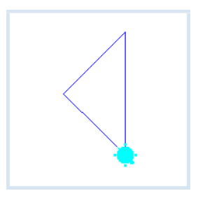

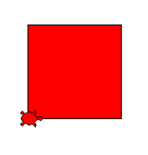

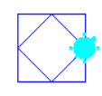

Attach a screenshot of your work here (or) Paste your code here as plain text.

Additional Exercise

If you have completed the codes for drawing the images attached in PPT T2-Turtle Features, attach a screenshot of your work here (or) paste your code here as plain text.